Name: Sajjal Tariq
Roll no: 10011
Section: BSCS (A)

Object-Oriented Programming
Lab No: 01

Task 1: Write a program that stores your name, age, and GPA in variables and prints them.
Program with output:
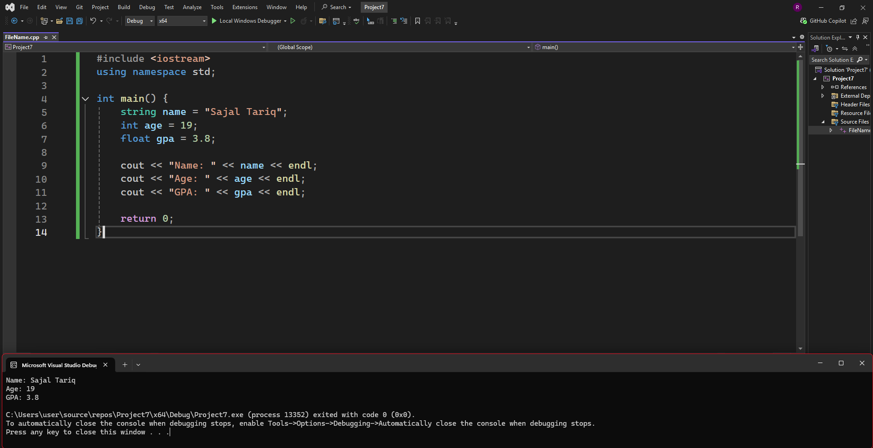

Task 2: Ask the user to enter two integers and print their sum, difference, product, and division.
Program with output:
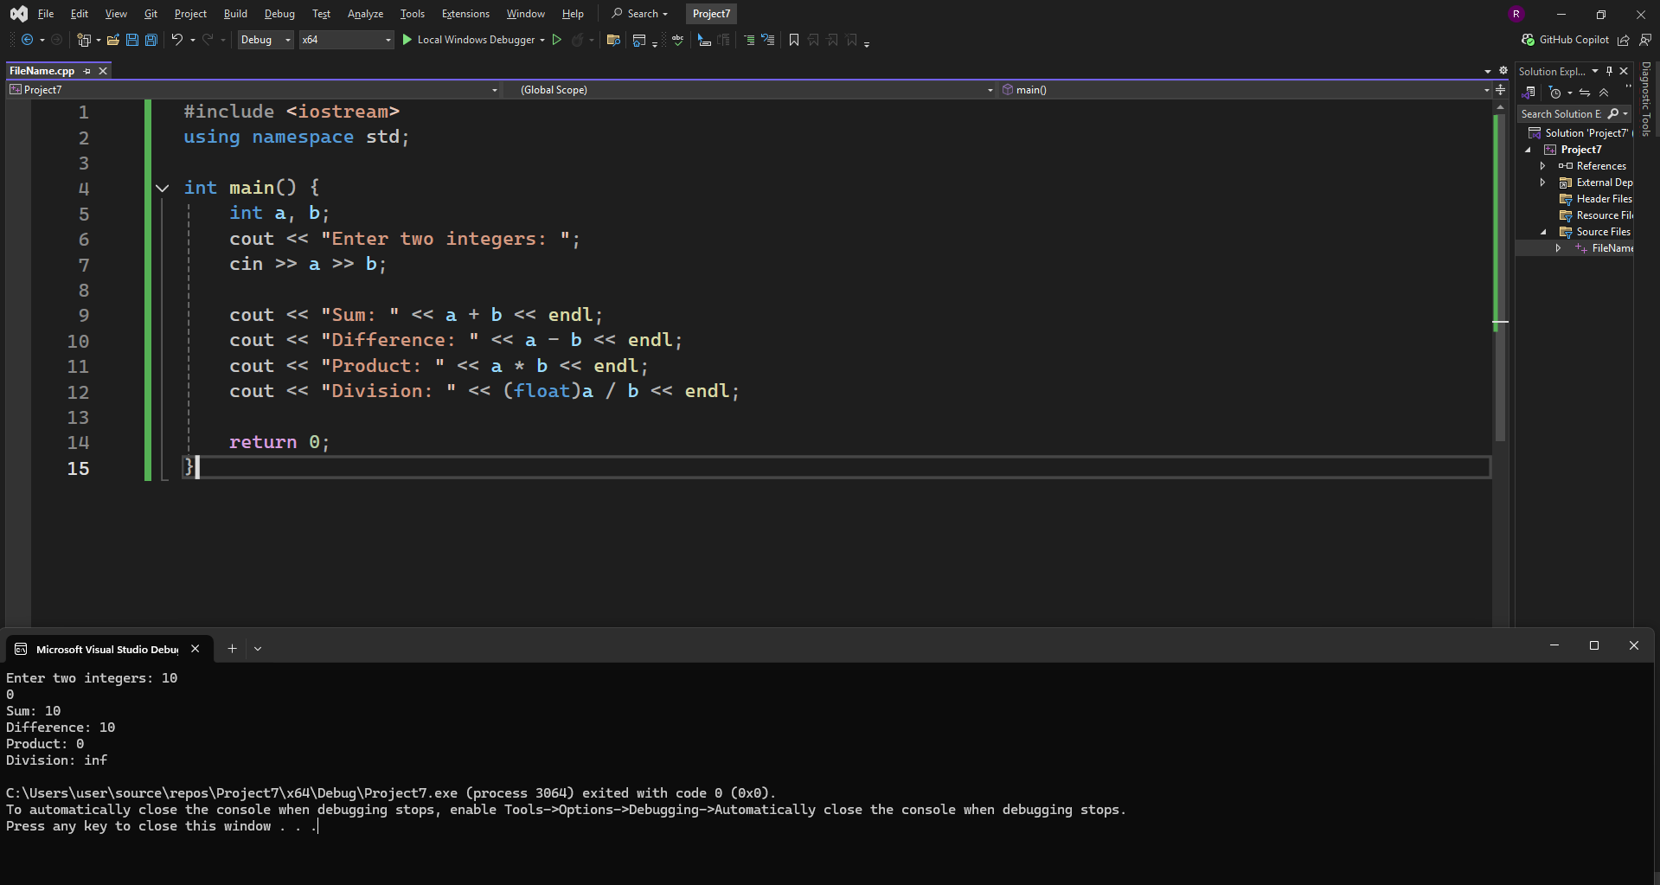

Task 3: Declare variables of different data types (int, float, char, string, bool) and print their values.
Program with output:
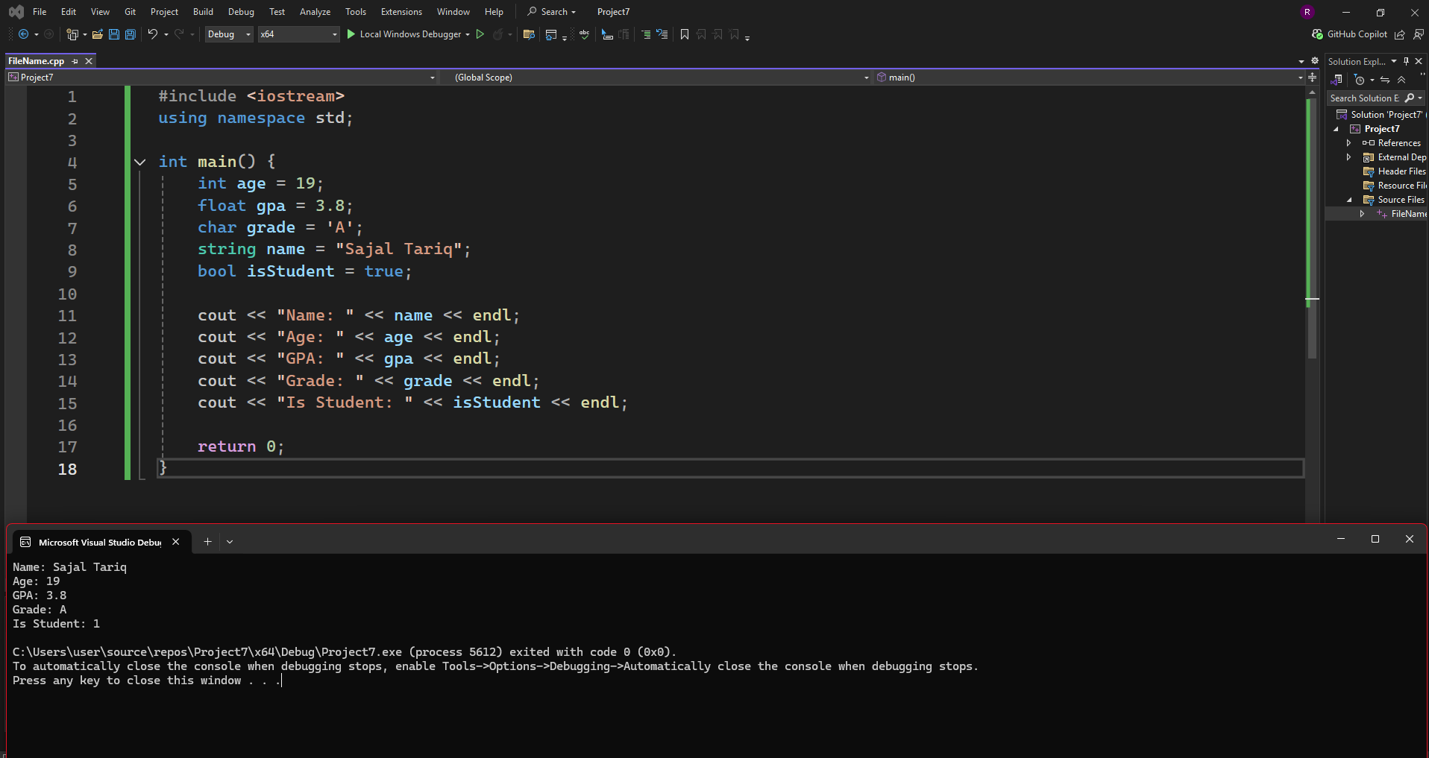
- Task 4: Print numbers from 1 to 10 using a loop.
Program with output:
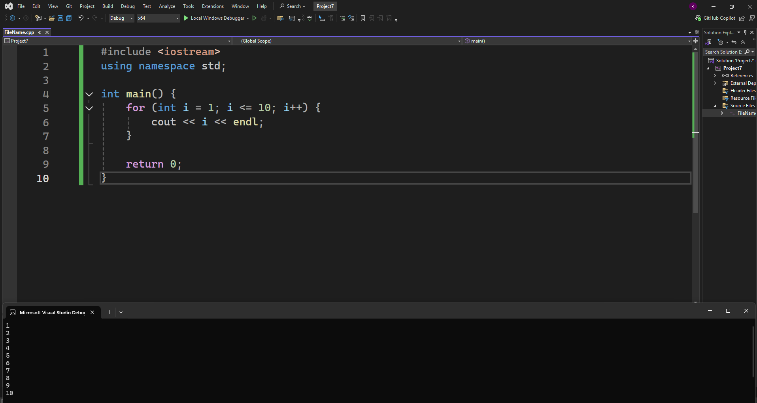

Task 5: Print the multiplication table of 5 using a loop.
Program with output
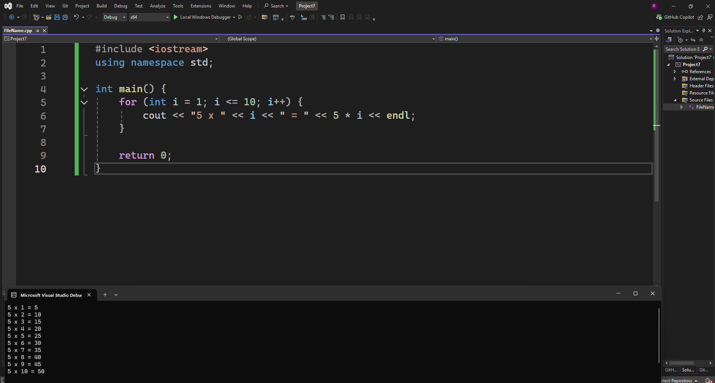
Task 6: Find the sum of all even numbers from 1 to 100.
Program with output
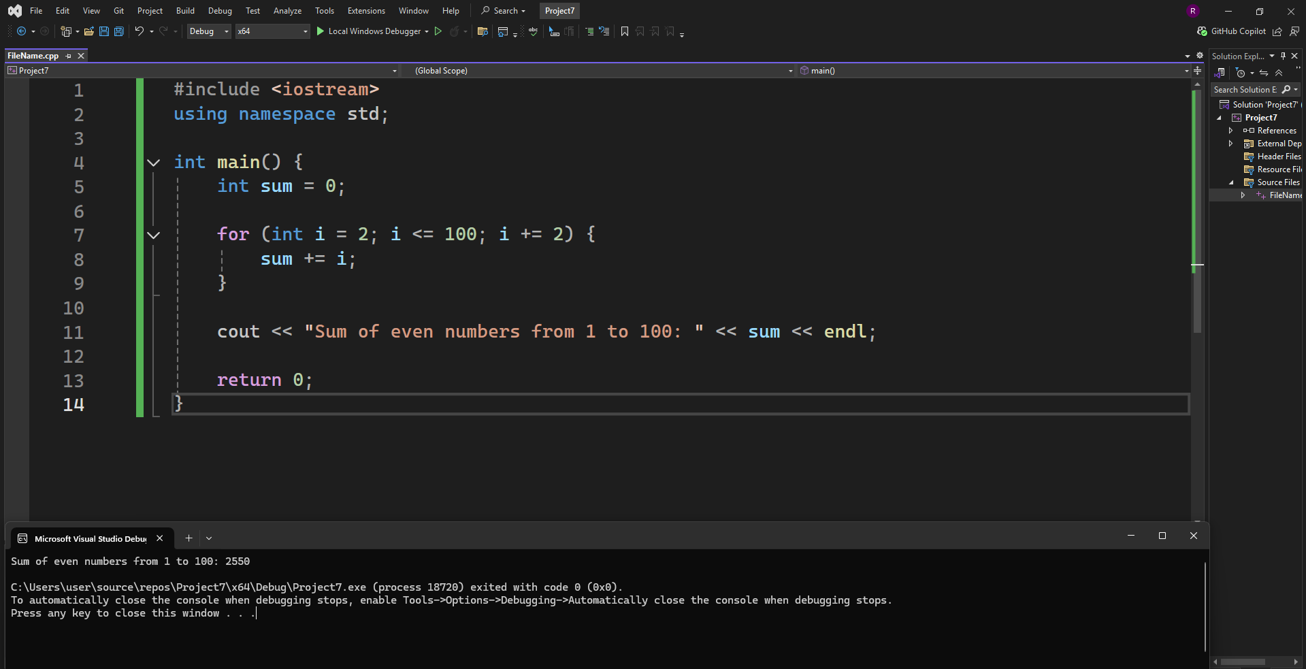
Task 7: Write a program to check whether a given number is prime or not (using loop).
Program with output
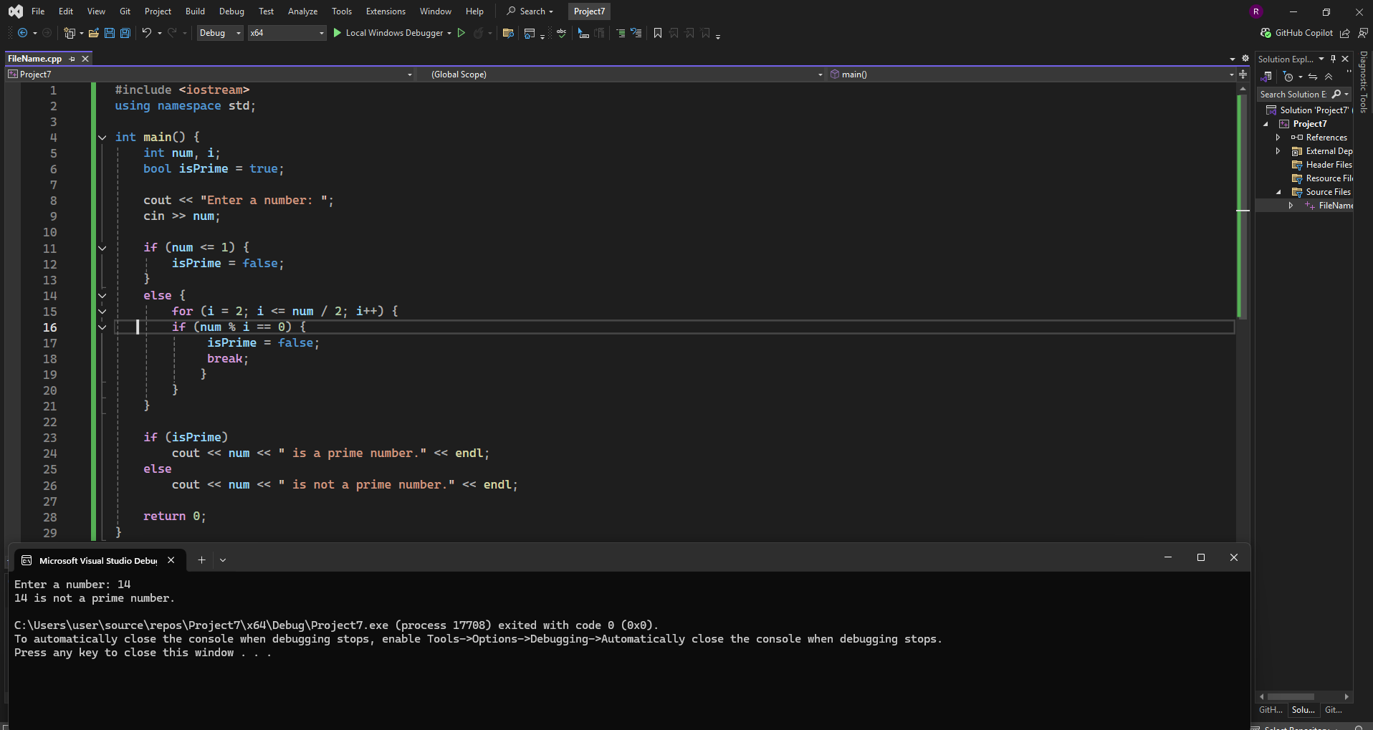
Task 8: Write a function add(int a, int b) that returns the sum of two numbers.
Program with output
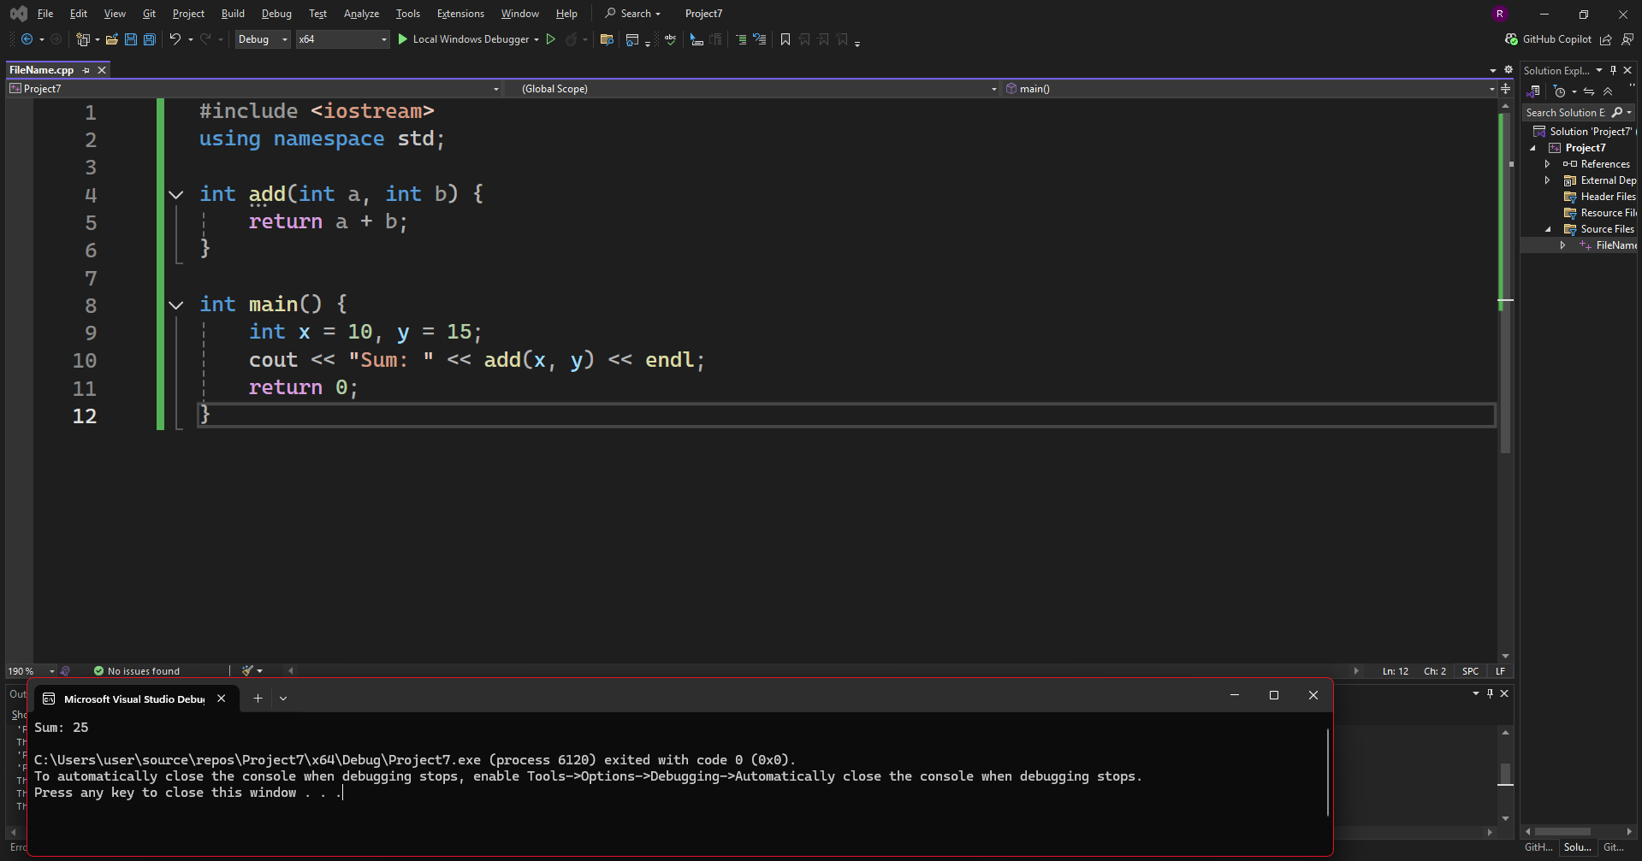

Task 9: Write a function factorial (int n) that returns the factorial of a number.
Program with output
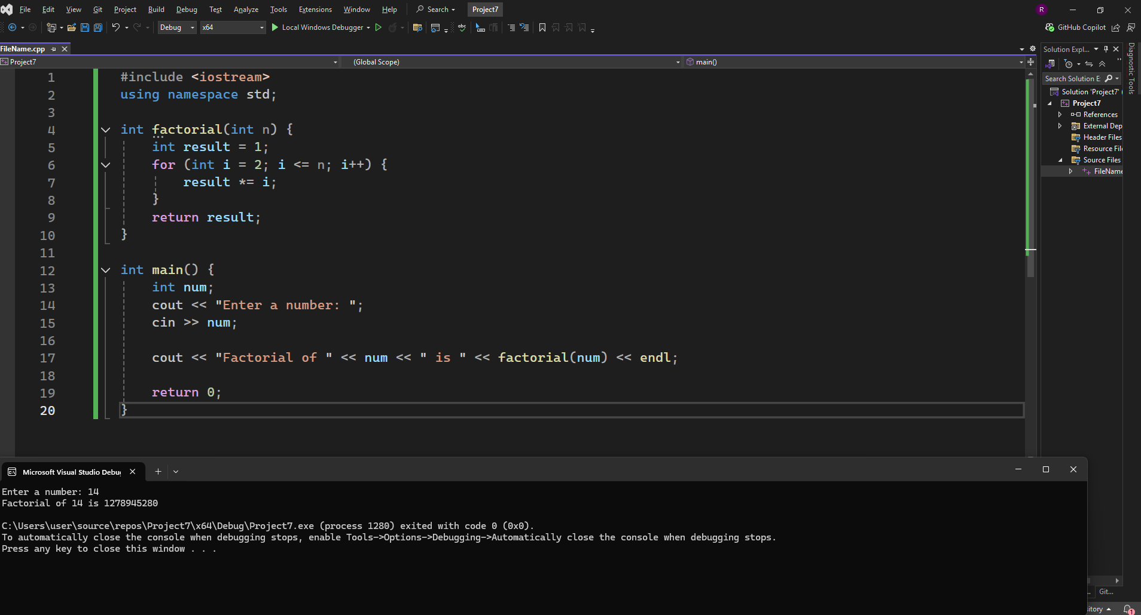
Task 10: Write a function isEven(int n) that returns true if the number is even, otherwise false.
Program with output
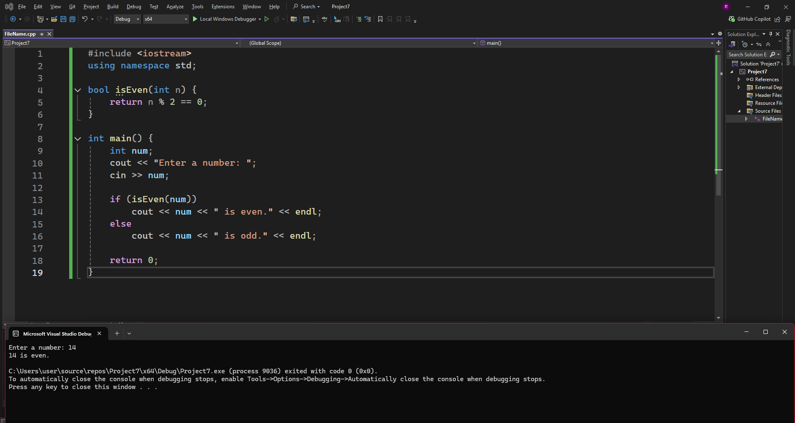
Task 11
Write a function power(int base, int exponent) that calculates base^exponent (without using built-in pow).
Program with output
